Objective:

Create a very basic API using tools and languages of your choice. The API will have a single endpoint/method with a single function.

API Input

User Location - The API will receive a latitude and longitude value which describes the current location of a user.

Business Requirements

The API will receive a latitude/longitude, using the provided list in pharmacies.csv the API will calculate the closest pharmacy to the input latitude/longitude. 2. The API will return the closest pharmacy (with name and address) in a consumable response packet. 3. The API will include the distance (in miles) between the input latitude/longitude and the selected closest pharmacy in the response packet.

Technologies Used

Spring Boot, H2, STS, JPA, JDK 1.8

Execution

Download the code, extract it and Open with spring tool suite.

Go to src/main/java

Open the model’s package

Run the LocationApiApplication class as java application and wait until spring is started.

Provide the latitude and longitude in URL like below

<http://localhost:8083/api/loc?latitude=39&longitude=-94>

Approach followed

Created Location table using JPA concept

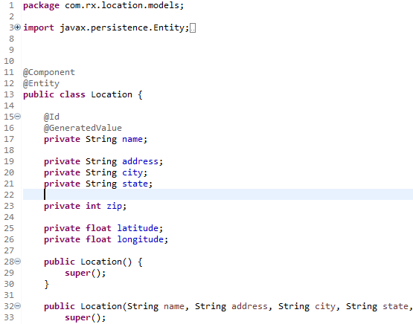

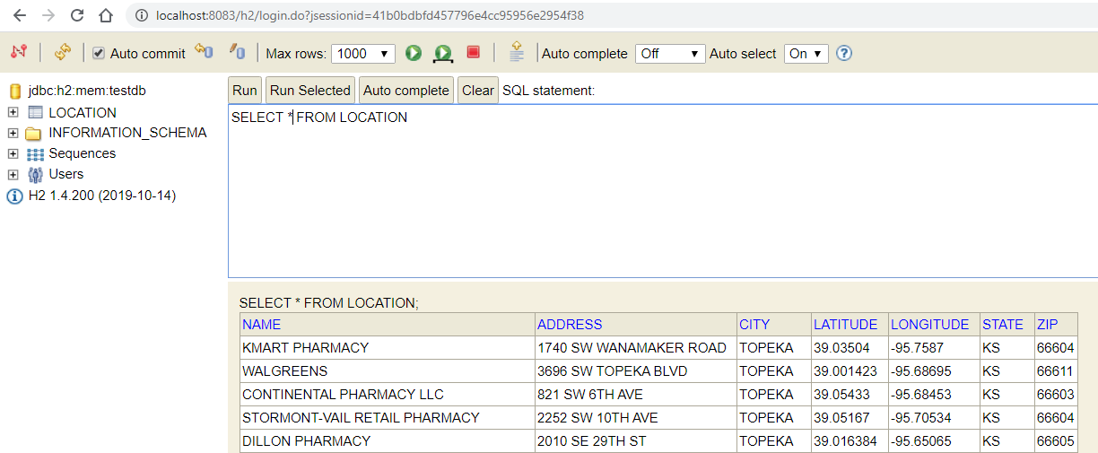

Inserted data from csv to H2 database.(data.sql)

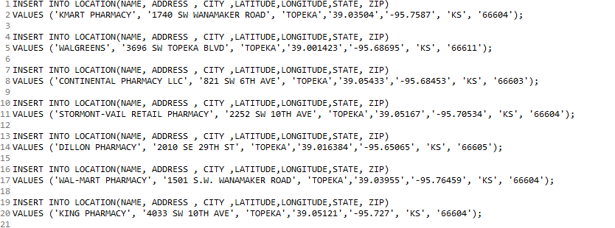

Created API findByLatAndLong which accepts latitude, longitude as input

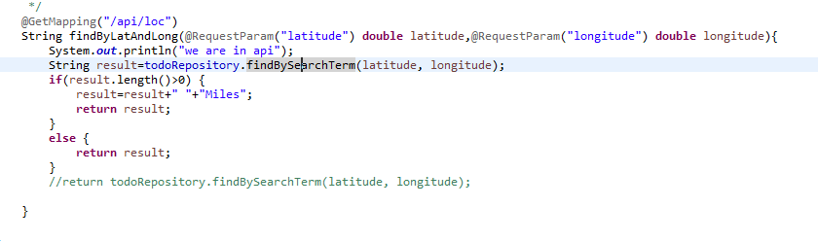

Which calls the repository, where our query ( SELECT top 1 name, SQRT(POWER(69.1 \* (latitude - :latitudein), 2) +POWER(69.1 \* (:longitudein- longitude) \* COS(latitude / 57.3), 2)) as Distance FROM LOCATION order by Distance ASC)

get the record which is nearer to our requested latitude and longitude

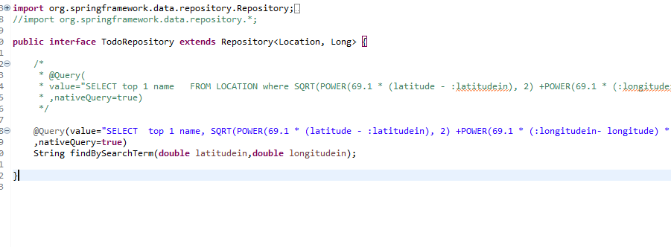

Our API will get the result, and I have returned the result.

OUTPUT

The output is generated as below, showing the store name and distance in miles.

<http://localhost:8083/api/loc?latitude=39&longitude=-95>

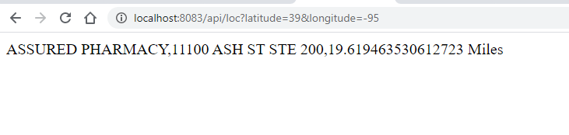

When exact point (pharmacy location) in db is given

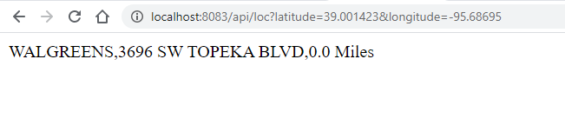

Improvements

Using CSV reader for inserting data to H2

References

<https://stackoverflow.com/questions/2234204/find-nearest-latitude-longitude-with-an-sql-query>

<https://spring.io/projects/spring-boot>